Class notes
Chapter 5: DISCRETE PROBABILITY DISTRIBUTIONS

Section 5.2: Random Variables

#6 p.205. Identifying Discrete and Continues Random Variables.

- The cost of conducting a genetics experiment.

- The number of supermodels who ate pizza yesterday.

- The exact life span of a kitten.

- The number of statistic professors who read a newspaper each day

- The weight of a feather.

#8 p.204 Identify Probability Distributions.
A researcher reports that when groups of four children are randomly selected from a population of couples meeting certain criteria, the probability distribution for the number of girls is a given in the accompanying table.

x | 0 | 1 | 2 | 3 | 4
P(x) | 0.502 | 0.365 | 0.098 | 0.011 | 0.001

- Determine whether a probability distribution is given.

- Find its mean and standard deviation

#12 p205. (Identify an unusual event)
In a study of brand recognition of Sony, groups of four consumers are interviewed. If x is the number of people in the group who recognize the Sony brand name, then x can be:

and the corresponding probabilities are 0.0016, 0.0250, 0.1432, 0.3892, and 0.4096
Is it unusual to randomly select four consumers and find that none of them recognize the brand name of Sony?

#18 p206. Expected Value in Casino Dice
When you give a casino $5 for a bet on the “pass line” in a casino game of dice, there is a 251/495 probability that you will lose $5 and there is a 244/495 probability that you will make a net gain of $5. (If you win, the casino gives you $5 and you get to keep your $5 bet, so the net gain is $5.) What is your expected value? In the long run, how much do you lose for each dollar bet?

#18 p206. Expected Value for a life insurance Policy
The CAN Insurance Company charges a 21-year-old male a premium of $250 for a one-year $100,000 life insurance policy. A 21-year-old male has a 0.9985 probability of living for a year.
- From the perspective of a 21-year-old male (or his estate) , what are the values of the two different outcomes?

- What is the expected value for a 21-year-old male who buys the insurance?

- What would be the cost of the insurance policy if the company just breaks even (in the long run with many such policies), instead of making a profit?

Section 5.3: Binomial Probability Distributions

Notation for Binomial Probability Distributions

S and F (success and failure) denote two possible categories of all outcomes;
p and q will denote the probabilities of S and F, respectively, so

P(S) = p (p = probability of success)
P(F) = 1 – p = q (q = probability of failure)

Also
n denotes the number of fixed trials.
x denotes a specific number of successes in n trials, so x can be any whole number between 0 and n, inclusive.
p denotes the probability of success in one of the n trials.
q denotes the probability of failure in one of the n trials.

P(x) denotes the probability of getting exactly x successes among the n trials.

# 5-9 p. 215. Identifying Binomial Distributions.

Determine whether the given procedure results in a binomial distribution.

- Randomly selecting 12 jurors and recording their nationalities.

- Randomly selecting 12 jurors and recording whether there is a “no” response when they are asked if they have ever been convicted of felony.

- Treating 50 smokers with Nicorette and asking them how their mouth and throat feel.

- Treating 50 smokers with Nicorette and recording whether there is a “yes” response when they are asked if they experience any mouth or throat soreness

- Recording the number of children in 250 families.

#14 p.215 Finding Probabilities When Guessing Answers.
A test consists of multiple-choice questions, each having four possible answers (a, b, c, d), one of which is correct. Assume that you guess the answers to six such questions.

- Use the multiplication rule to find the probability that the first two guesses are wrong and the last four guesses are correct. That is, find P(WWCCCC), where C denotes a correct answer and W denotes a wrong answer.

- Beginning with WWCCCC, make a complete list of the different possible arrangements of two wrong answers and four correct answers, then find the probability for each entry in the list.

- Based on the preceding results, what is the probability of getting exactly four correct answers when six guesses are made?

Example 3 .Using the Binomial Probability Formula.
It can be very difficult to make sales by means of telephone transactions. Suppose that it is known that only 10% of all business calls result in a sale. What is the probability that out of the next 15 such calls, exactly 3 will result in a sale?

Example 4 .Using A-1 table.
There are 12 students in a study group. Forty percent of the students are female. The instructor randomly selects 5 students to attend a lecture on quality control and industrial statistics.
- What is the probability that at most 2 of the 5 students selected will be female?

- What is the probability that more than 3 students selected will be female?

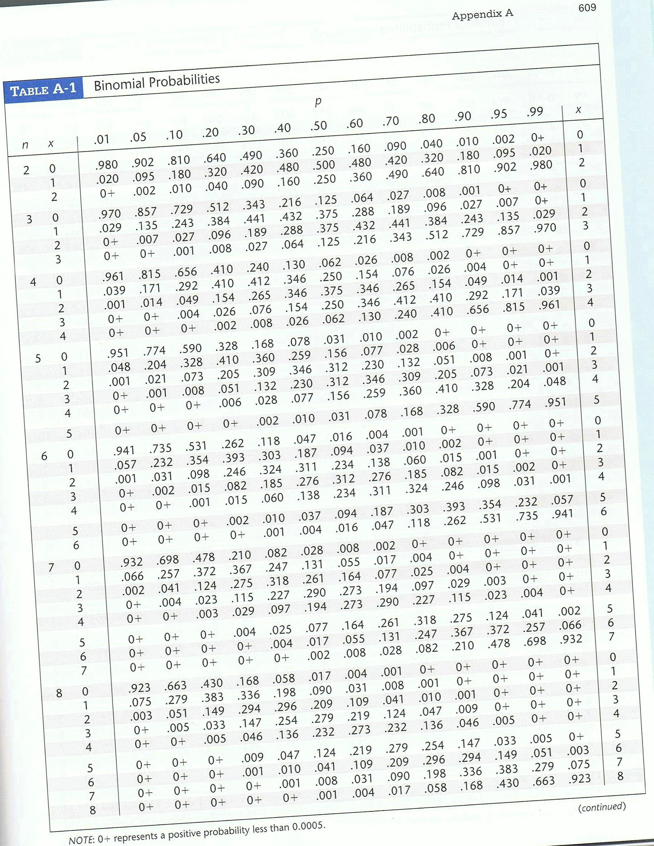

#31 p 217. Acceptance Sampling
The Medassist Pharmaceutical Company receives large shipments of aspirin tablets and uses this acceptance sampling plan: Randomly select and test 24 tablet, then accept the whole batch if there is only one or none that doesn’t meet the required specifications. If a particular shipment of thousands of aspirin tablets actually has a 4% rate of defects, what is the probability that this whole shipment will be accepted?

Section 5.4: Binomial Probability Distributions: Mean, Variance, and Standard Deviation
#10 p 222. Guessing Answers
Several economics students are unprepared for a multiple –choice quiz with 25 questions, and all of their answers are guesses. Each question has five possible answers, and only one of them is correct.
- Find the mean and Standard deviation for the number of correct answers for such students.

- Would it be unusual for a student to pass by guessing and getting at least 15 correct answers? Why or why not?

